**Statistical Analysis - ST 511**

**Homework –7** 11/22/2020

**Name: Vipul Chitnis**

**OSU I’d: 934295664**

**1 a)**

R Code:

qplot(Method, Stiff, data=HW7Dat, geom="boxplot")

Output:

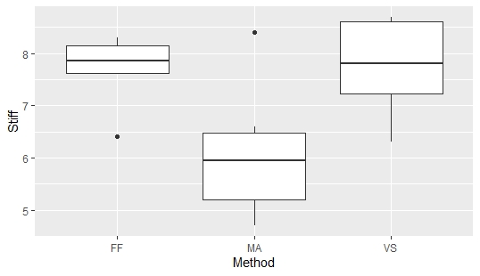

1 b)

R Code:

>HW7Dat_aov <- aov(Stiff~Method, data = HW7Dat)

>anova(HW7Dat_aov)

Output:

Analysis of Variance Table

Response: Stiff

Df Sum Sq Mean Sq F value Pr(>F)

Method 2 10.570 5.285 4.9811 0.02193 *

Residuals 15 15.915 1.061

---

Signif. codes: 0 ‘***’ 0.001 ‘**’ 0.01 ‘*’ 0.05 ‘.’ 0.1 ‘ ’ 1

1 c)

R Code:

>plot(HW7Dat_aov, which=1)

Output:

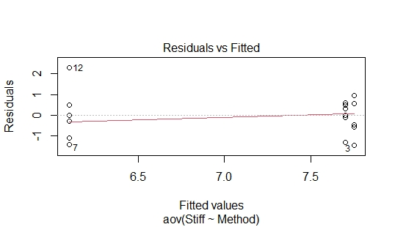

From the plot it is evident that it has a non-constant variation, hence the equal variance assumption may be violated. But the population looks normal as the data looks symmetrically distributed across 0 for all the three populations that is FF, MA, VS.

Q.No. 2a)

R Code:

>TukeyHSD(HW7Dat_aov)

Output:

Tukey multiple comparisons of means

95% family-wise confidence level

Fit: aov(formula = Stiff ~ Method, data = HW7Dat)

$Method

diff lwr upr p adj

MA-FF -1.60 -3.1447124 -0.05528756 0.0419027

VS-FF 0.05 -1.4947124 1.59471244 0.9961114

VS-MA 1.65 0.1052876 3.19471244 0.0356584

2 b)

The population means stiffness is estimated to be different for both MA-FF and VS-MA. (95% Tukey-Kramer CI).

Q.No. 3a)

summary(HW7Dat$Method)

FF MA VS

6 6 6

>HW7Dat_aov <- aov(Stiff~Method, data=HW7Dat)

>HW7Dat_glht<- glht(HW7Dat_aov, linfct=mcp(Method="Dunnett"))

>confint(HW7Dat_glht)

Simultaneous Confidence Intervals

Multiple Comparisons of Means: Dunnett Contrasts

Fit: aov(formula = Stiff ~ Method, data = HW7Dat)

Quantile = 2.4394

95% family-wise confidence level

Linear Hypotheses:

Estimate lwr upr

MA - FF == 0 -1.6000 -3.0507 -0.1493

VS - FF == 0 0.0500 -1.4007 1.5007

Ans 3 b)

We estimate differences between the population mean stiffness for MA and FF while no difference in population mean stiffness for VS and FF. (95%, Dunnett’s CI’s) (Refer table in answer 3 a).

Ans 4a)

Comparison between FF and average means of MA and VS

R Code:

>summary(HW7Dat$Method)

FF MA VS

6 6 6

>with(HW7Dat, unlist(lapply(split(Stiff, Method), mean)))

FF MA VS

7.70 6.10 7.75

>k<- 2

> (alpha <- 0.05/k)

0.025

> (M <- qt(1-alpha/2, 15))

2.48988

> (g1 <- 7.70 - (6.10 + 7.75)/2)

[1] 0.775

>HW7Dat_aov <- aov(Stiff~Method, HW7Dat)

>anova(HW7Dat_aov)

Analysis of Variance Table

Response: Stiff

Df Sum Sq Mean Sq F value Pr(>F)

Method 2 10.570 5.285 4.9811 0.02193 *

Residuals 15 15.915 1.061

Signif. codes: 0 ‘***’ 0.001 ‘**’ 0.01 ‘*’ 0.05 ‘.’ 0.1 ‘ ’ 1

>SE <- sqrt(1.061)*sqrt(1/6 + 2*(0.5)^2/6)

>SE

[1] 0.515024

> (g1 - M*SE)

[1] -0.5073485

> (g1 + M*SE)

[1] 2.057348

Comparison between the means of MA and VS

>g2 <- (6.10-7.75)

[1] -1.65

>(SE2 <- sqrt(1.061)*sqrt(1/6+1/6))

[1] 0.5946988

>(g2 - M*SE2)

[1] -3.130728

>(g2 + M*SE2)

[1] -0.1692715

Confidence interval for FF when compared to others is -0.507 to 2.05

Confidence interval for MA when compared to VS is -0.169 to -3.130

Q.No. 5

Ans 5a)

>(M <- sqrt(2*qf(0.95,2,15)))

>(g <- (6.10 - (7.70+7.75)/2))

>(SE <- sqrt(1.061) * sqrt(1/6 + 0.5^2/6 + 0.5^2/6))

>g - M*SE

>g + M*SE

The confidence interval for MA when compared to others is -0.237 to -3.023

Ans 5b)

Yes, Scheff´e confidence interval tells us that the population mean stiffness for method MA is different from the average population mean stiffness for the other two methods because zero is not in the confidence interval mentioned in ans 5a.